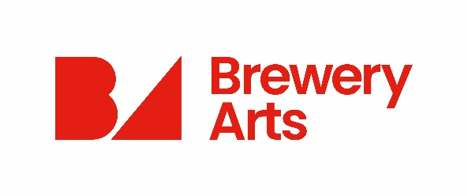
Volunteer
Expression of Interest Form

Thank you for your interest in becoming a Brewery Arts Volunteer. Our team of volunteers are invaluable to the running of the Brewery
Please return your completed application form to:

email recruitment@breweryarts.co.uk

or post to

Recruitment, Brewery Arts, 122a Highgate, Kendal LA9 4HE

- PERSONAL DETAILS
Title: | Mr/Mrs/Ms/Miss/Other
First name(s):
Surname:
Address:
Postcode:
Date of Birth:

- CONTACT DETAILS
Tel No. (Home): |  | Tel No. (Work):
Mobile:
Email:

- ADVERTISEMENT
Where did you learn about this job?
Brewery Website | Brewery Poster |  | Brewery Recruitment Email | Brewery Contact /Word of Mouth
Indeed | Do-it Website |  | Cumbria Volunteer Services (CVS) | Social Media
Other Method (please specify)

- CRIMINAL CONVICTIONS
Do you have any criminal convictions which are not ‘spent’ as defined by the Rehabilitation of Offenders Act 1974, or have you been subject to any caution or binding over orders in the last twelve months?
Yes No
If YES please give details of the offence, court and sentence. Continue on a separate sheet if necessary.

- REFERENCE
Please provide us with the name and details of an individual who would be willing to provide you with a reference.
Name:
Company if Applicable:
Address:
Postcode:
Email:
Tel No: |  | Mobile:
How do you know this person?

6. TYPE OF VOLUNTARY WORK?
Please let us know what type of voluntary work you would be interested in at Brewery Arts:

- AVAILABILITY
Please could you give us an idea of the amount of time you have available to volunteer:

9. SKILLS, EXPERIENCE, AND INTERESTS
Please tell us about the skills, experience and interests you have which is relevant to the type of voluntary work you would like to carry out at Brewery Arts.

11. PREVIOUS VOLUNTARY WORK
Please give details, including location and duration, of any previous or current voluntary work undertaken.

8. CONFIRMATION OF DETAILS
I certify that the information I have given in this document is correct. I understand that you may carry out checks on all of the information I have given and that by deliberately giving false or incomplete answers I will be disqualified from consideration for this post or, in the event of my appointment, may be dismissed without notice. I also understand that the appointment may be subject to satisfactory references and a Disclosure & Barring Service (DBS) check if applicable.

Signature …………………………………………………………. Date
Our Privacy Notice for Applicants details how we process and protect your personal information.

Thanks again for your interest!

