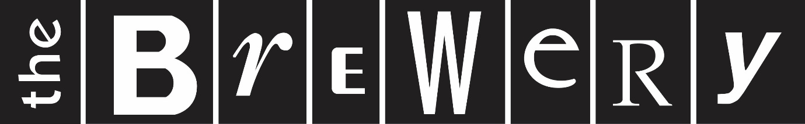

Applied Theatre in Cumbria Apprentice Actors Info
Applied Theatre in Cumbria is a two year partnership project between South Lakeland District Council and Brewery Arts Centre funded through Curious Minds, South Cumbria Community Safety Partnership, Cumbria Police and Crime Commissioner and South Lakeland Health and Wellbeing Forum.
We are currently looking for 3 enthusiastic, talented and committed young actors to perform in a brand new piece of immersive theatre created specifically for this project. Working with a team of professional theatre makers, and 3 professional actors, the immersive piece will take place in 2 separate venues, one in Kendal and one in Barrow during May 2019. The developed piece will be based around the national issue of County Lines.

You must:
- Be aged between 16-23
- Have acting/performing experience at ‘A’, BTEC or graduate level
- Be available for audition on Thursday April 4th at Brewery Arts Centre
- Be available for the following rehearsal dates:
Tues 23rd-Fri 26th April | Daytime
Mon 29th April-Thurs 2nd May | Daytime
Mon 6th- Fri 10th May | Daytime

- Be available for evaluation w/b 27th May (date and time to be confirmed)

Performances will take place in 2 venues, Kendal and Barrow, with young people from Year 9 in local schools, transported to the venue so will, therefore, be during the day. In addition you will be required to attend 2 teachers’ workshops, one in Kendal on Apr 30th and one in Barrow on May 1st.

Performance dates are May 13th – 24th.

You will be contracted as an apprentice actor and will receive remuneration of £250 per week for 5 weeks. You will also receive a per diem payment to cover the cost of food whilst on tour and transport to the venues will be provided.

The audition will last approx. 1 hour and will be a workshop style process consisting of warm up, short improv session and text work. Text will be provided on the day. Actors are not required to prepare anything. Please bring suitable clothing and footwear for the workshop.
To apply for audition please send a copy of your acting CV with a short statement explaining why you would like to be considered for this project to tricia.gordon@breweryarts.co.uk Deadline for application is Wednesday 27th March

